Motricity Exercise

User Guide

1. Start an exercise 2

1.1. Static exercise 3

1.2. Dynamic exercise 5

2. User management 7

2.1. Patient 7

2.1.1. Add a patient 7

2.1.2. Consult a patient 9

2.1.3. Edit a patient 10

2.1.4. Delete a patient 12

2.2. Operator 14

2.2.1. Add an operator 14

2.2.2. Consult an operator 16

2.2.3. Edit an operator 18

2.2.4. Delete an operator 19

3. Tests results management 21

3.1. Consult a test 22

3.2. Consult a result as a graph 22

3.3. Delete a test 22

3.4. Exports tests 22

4. Export mode settings 22

# Start an exercise

**Prerequisites:**

* You must have created a patient and an operator before starting any exercise. Refer to user management part to see how to proceed.
* You will need to draw 3 points aligned at equal distance and use a tripod to prop up the phone so that it films the whiteboard. You can then position the patient and prepare yourself, as shown in the diagram, as follows on this plan

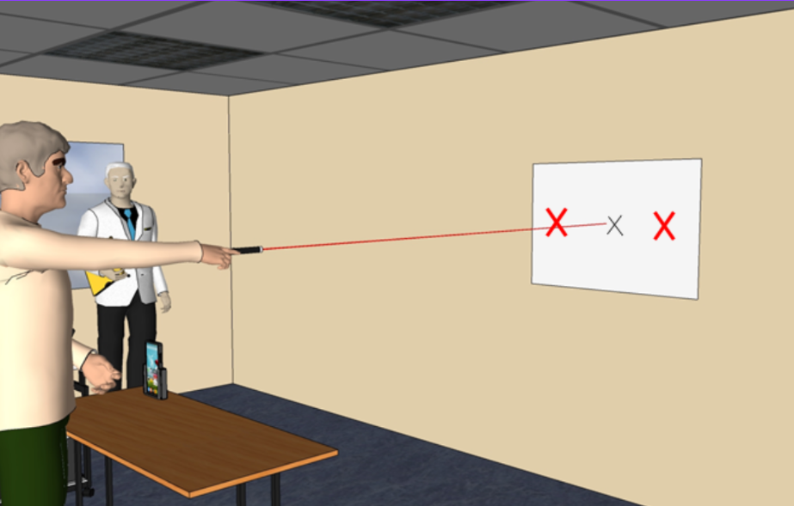

## Static exercise

* Launch the application

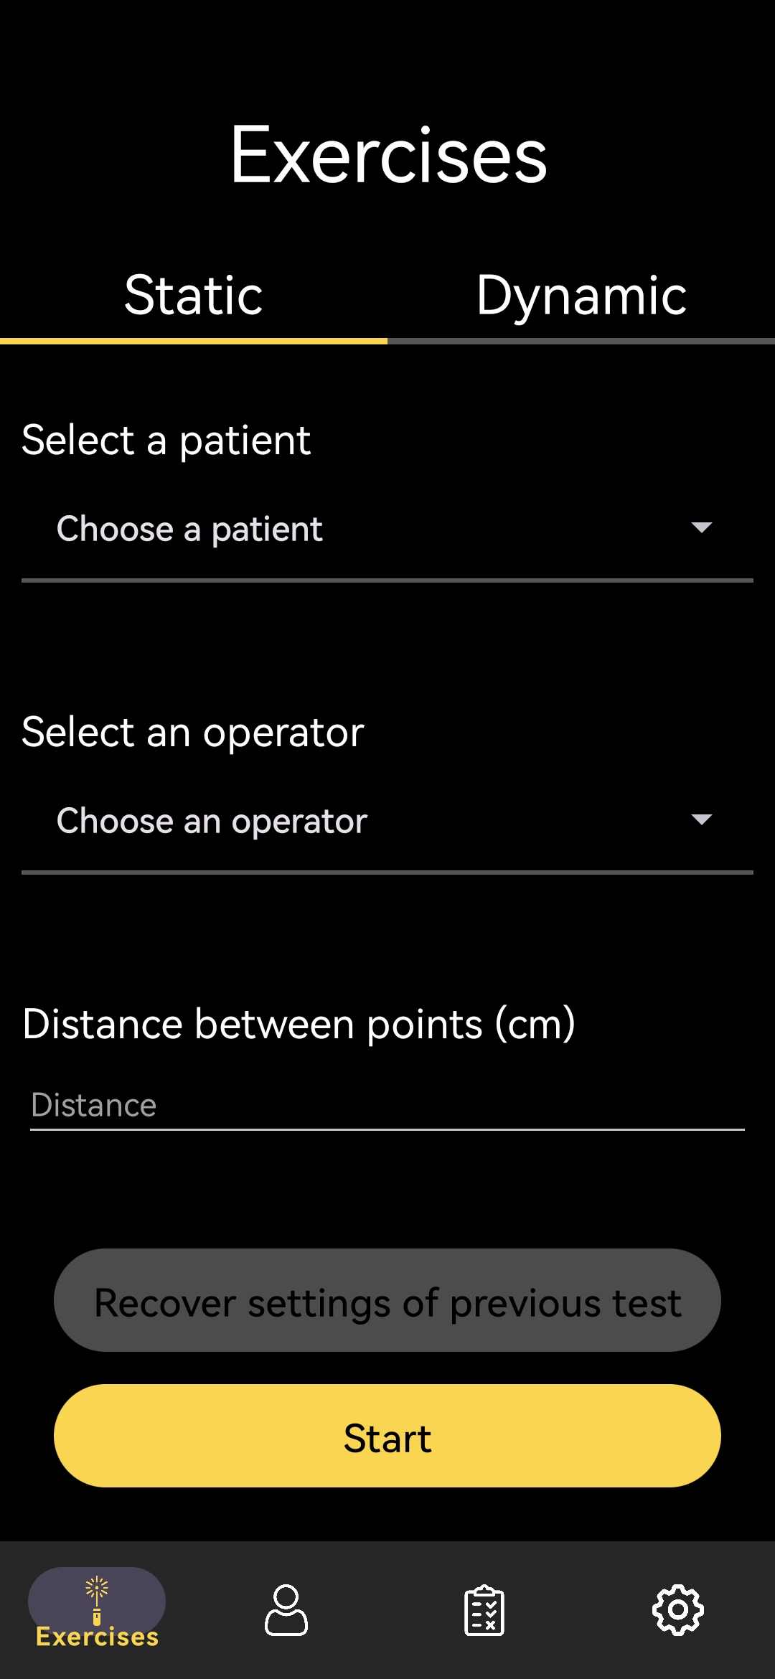

* Choose a patient in the dropdown list, available by clicking on the section “Choose a patient”

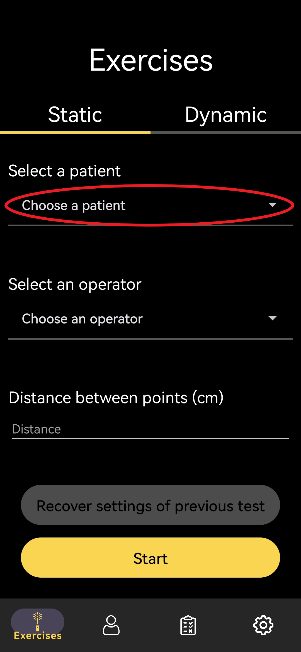 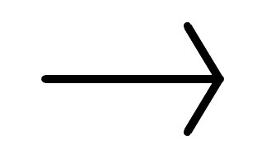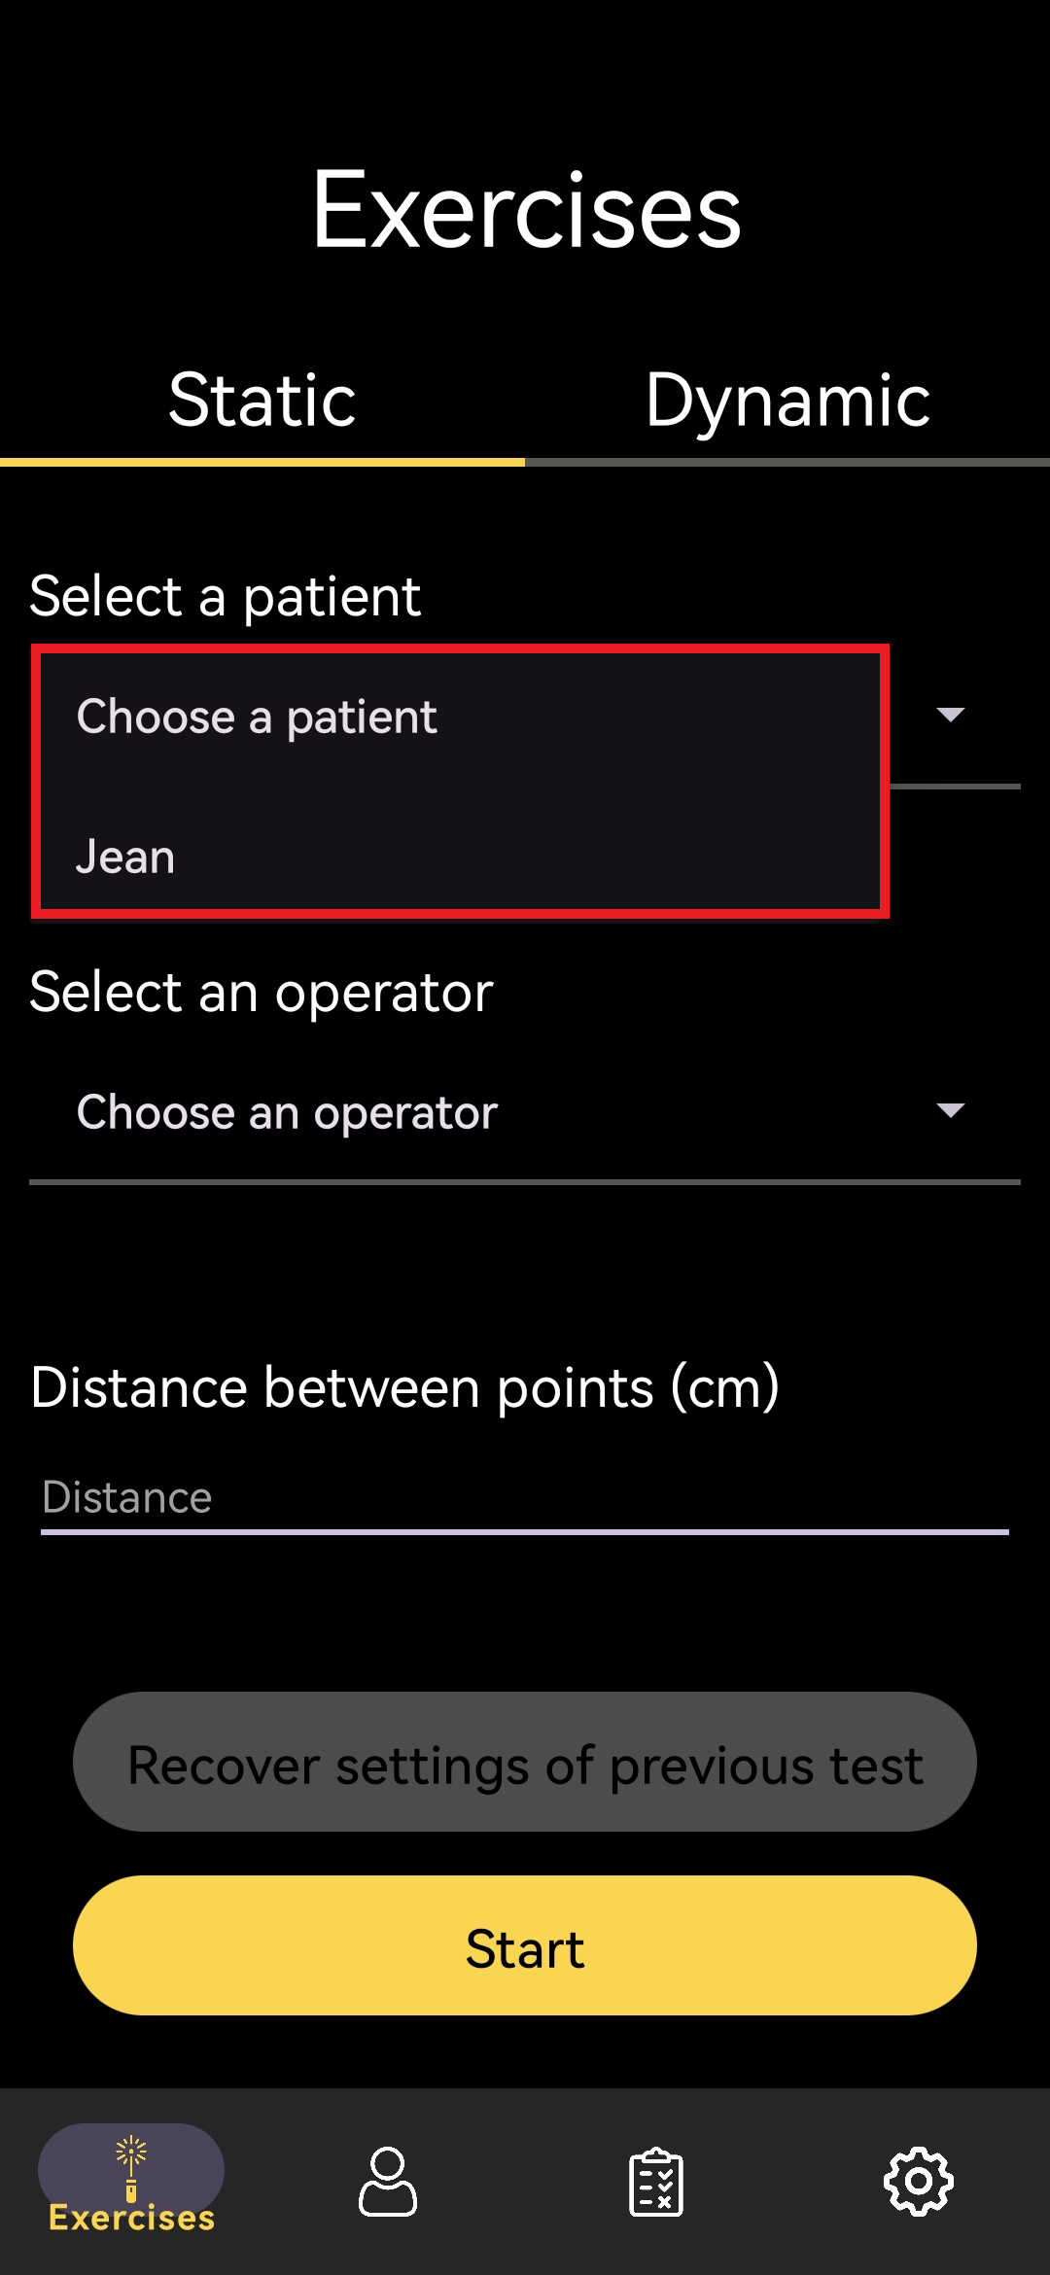

* Choose an operator in the dropdown list available by clicking on the section “Choose an operator”

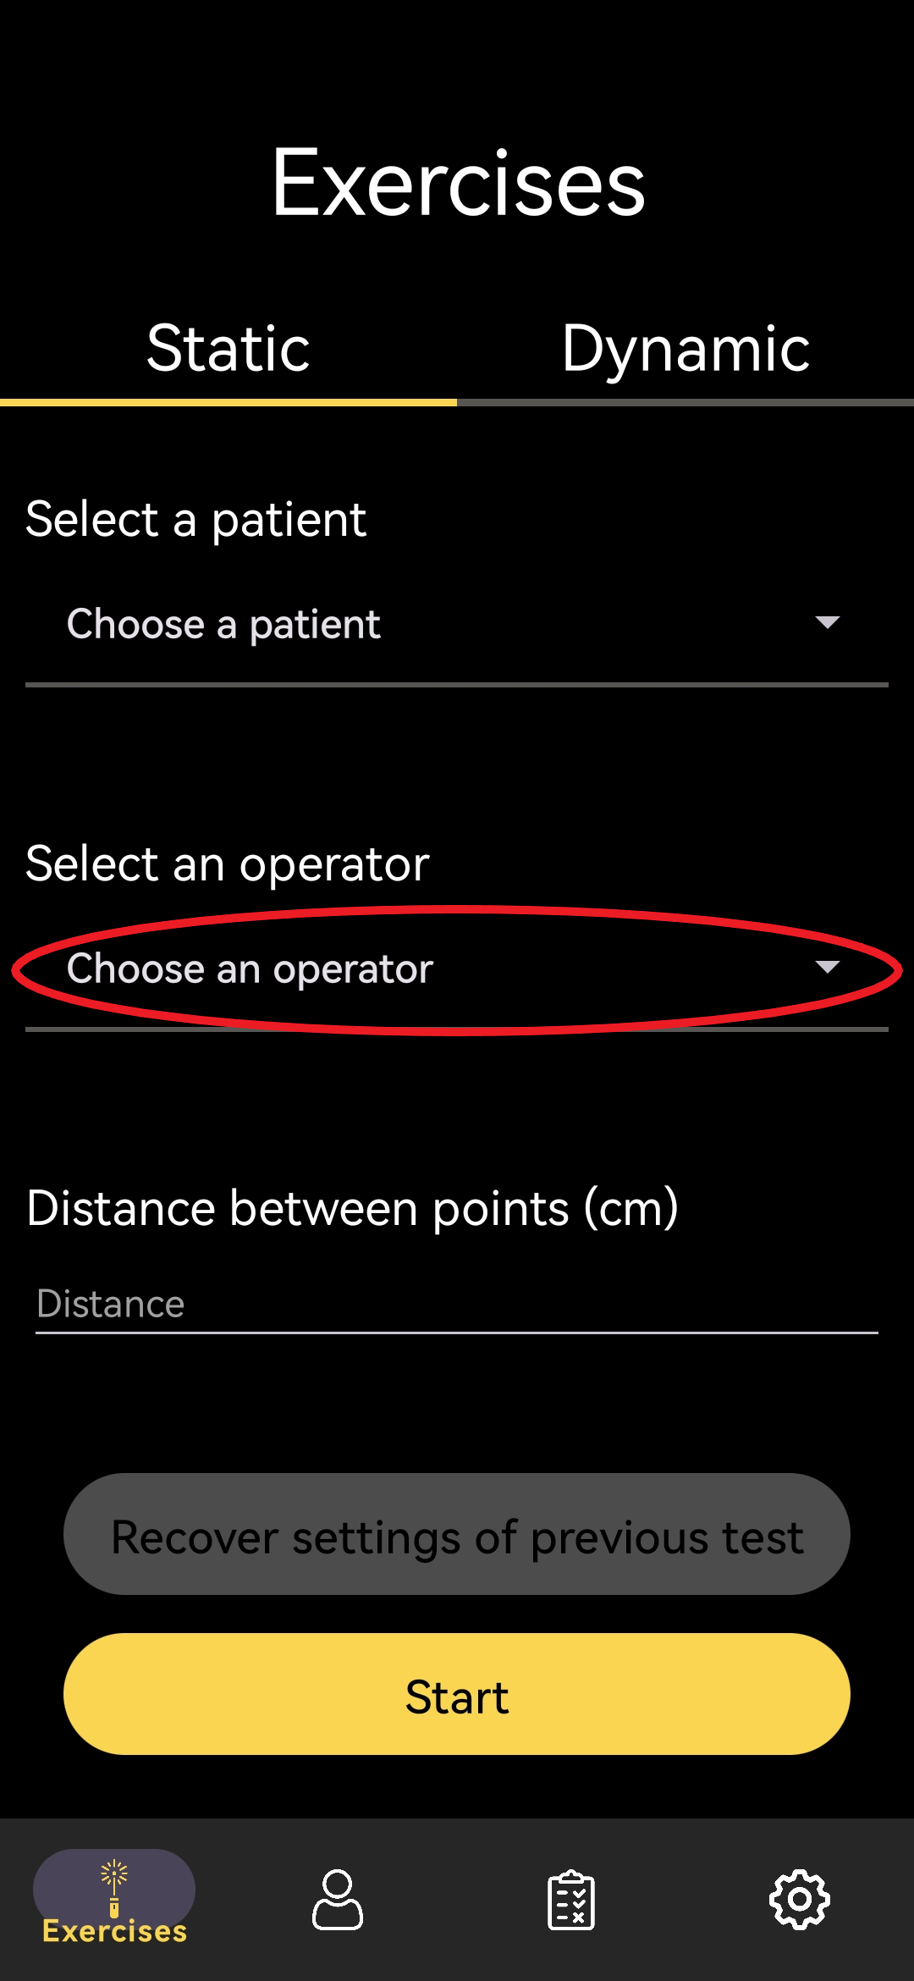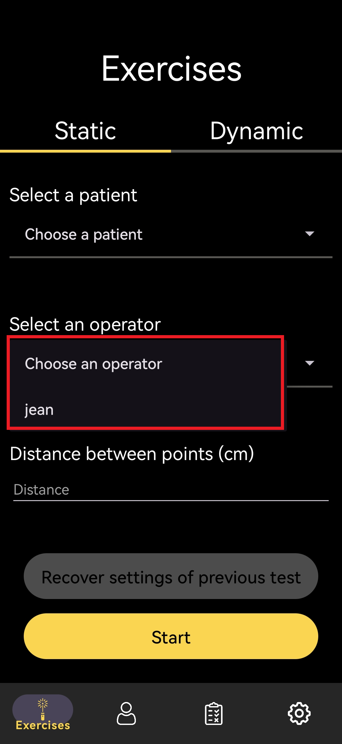

* Type the distance between the two points drawn on the whiteboard in the field “Distance between points (centimetres)”

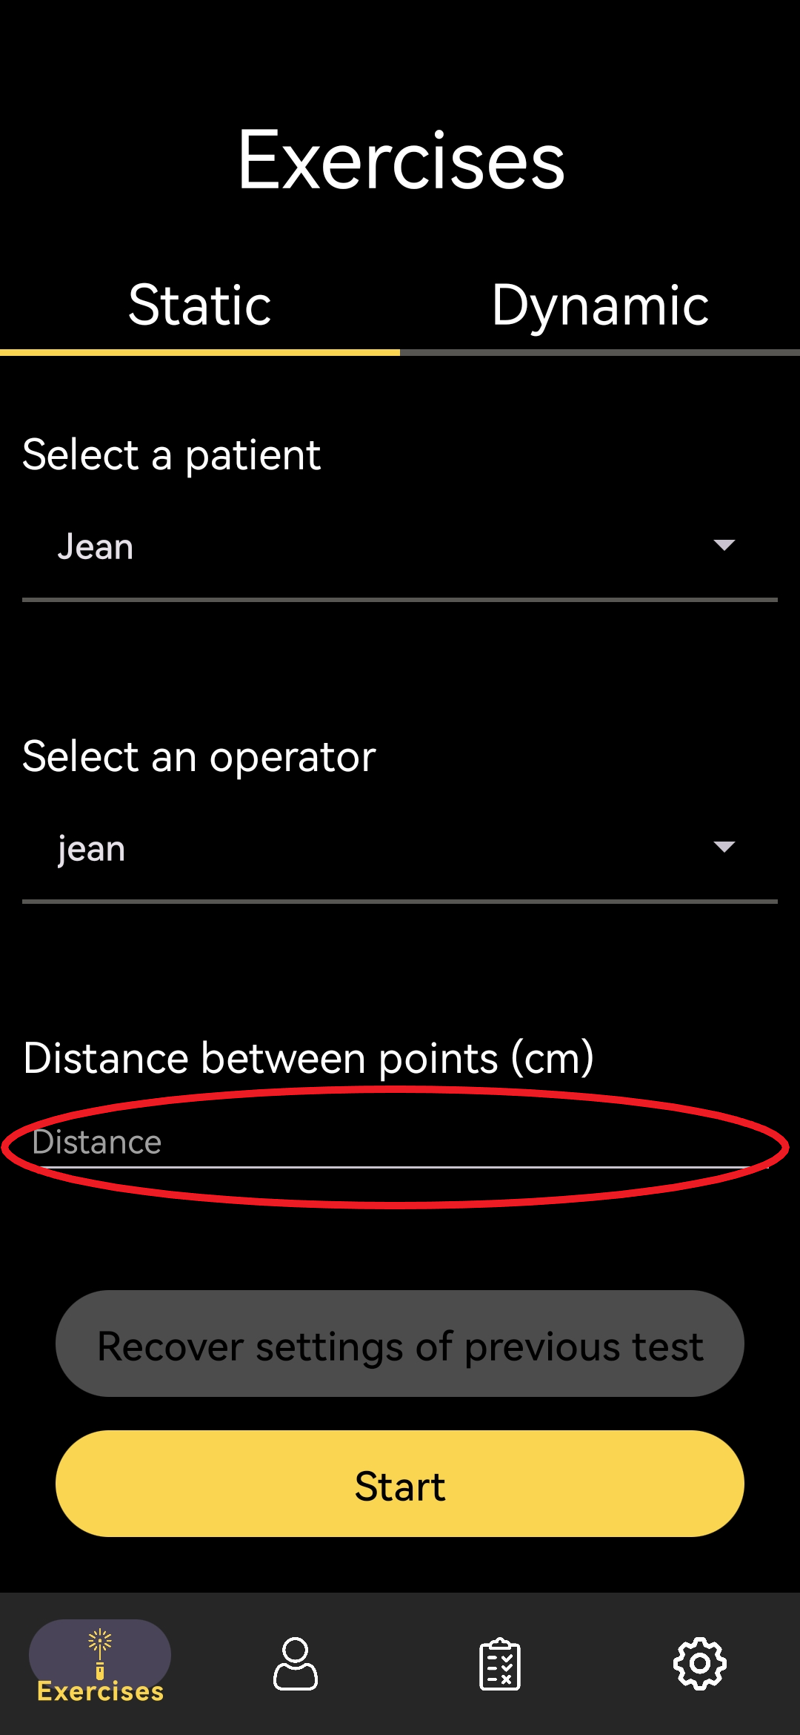

* Type the exercise duration in the field “Time of the exercise (seconds)

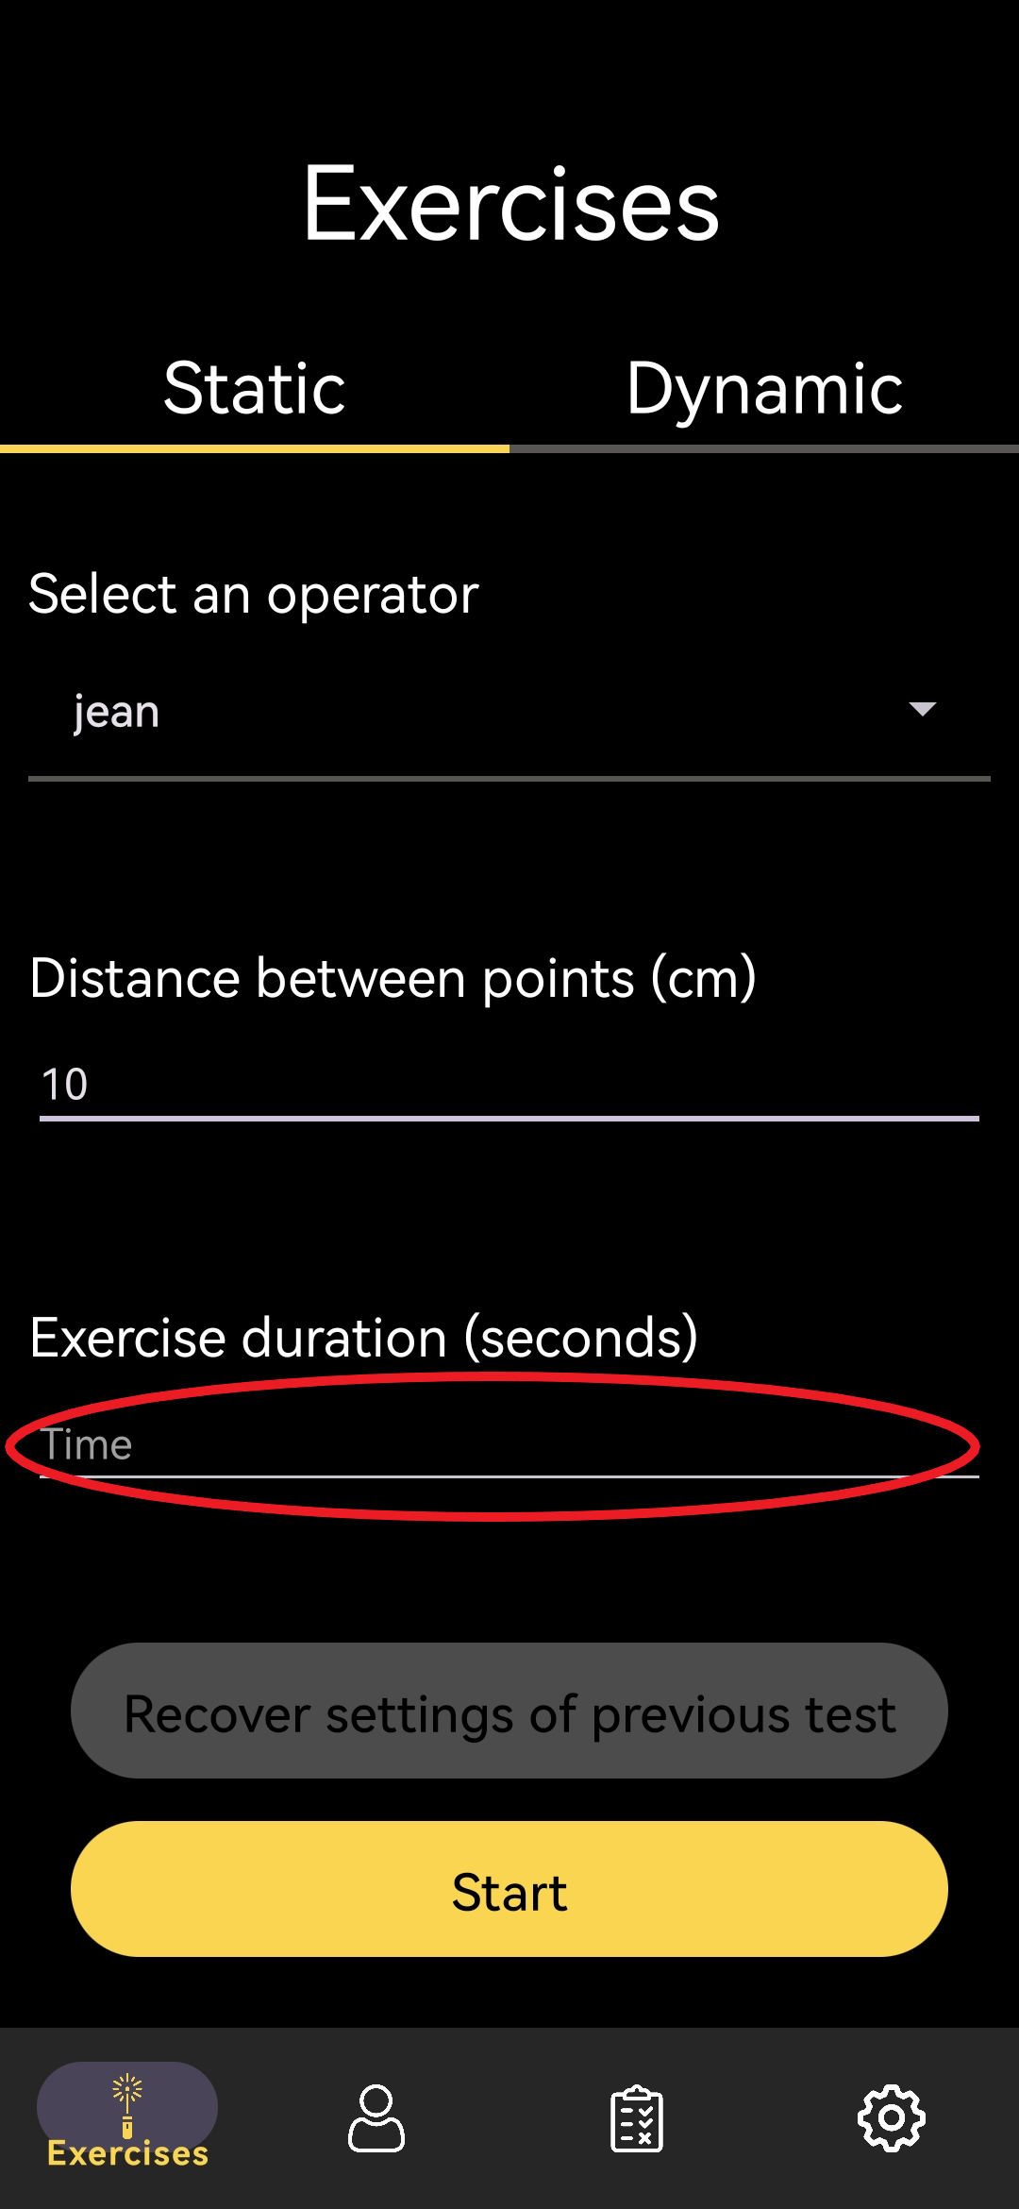

* Then, click "Start" to begin the exercise

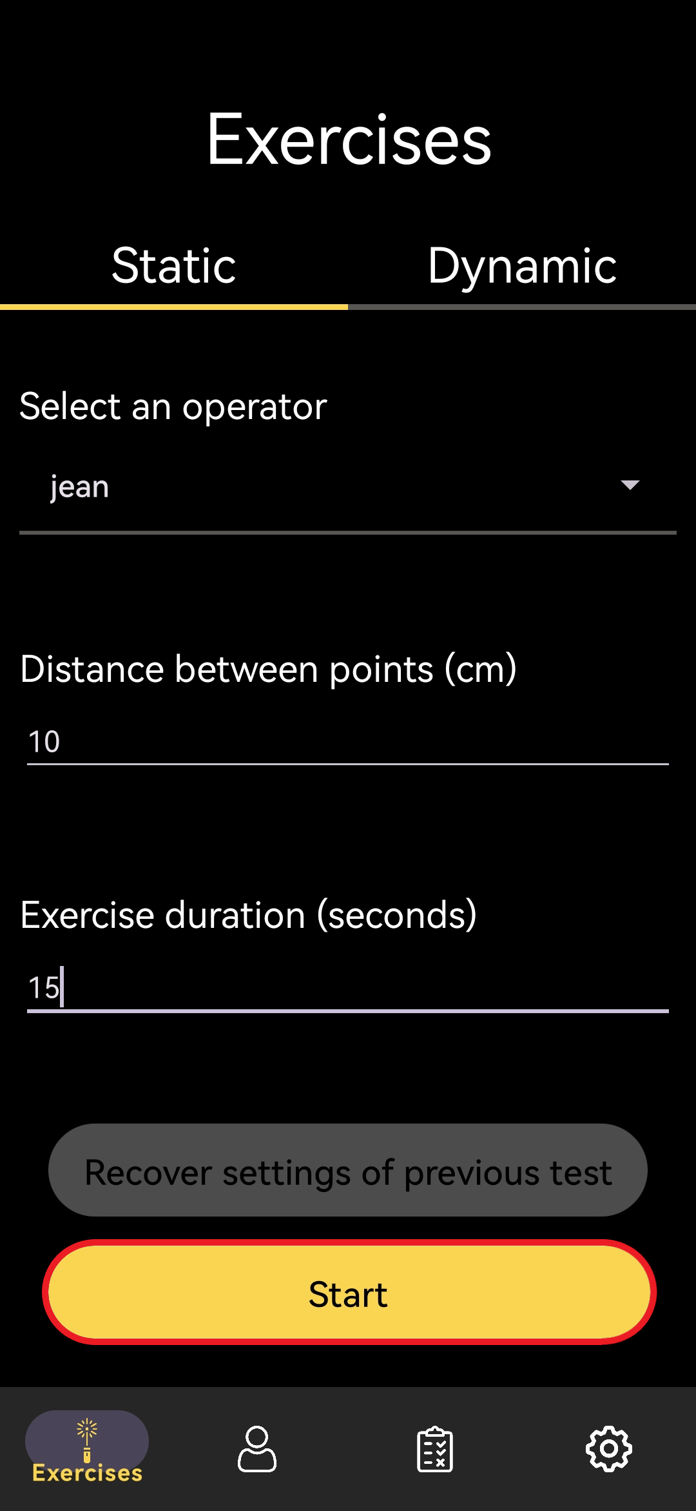

## Dynamic exercise

* Launch the application



* Click on the "Dynamic" section

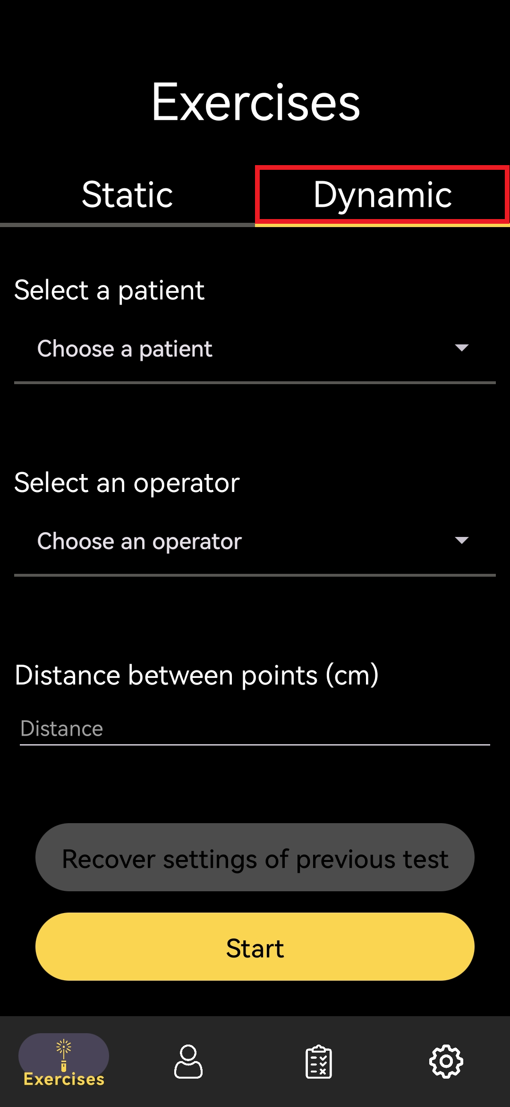

* Choose a patient in the dropdown list, available by clicking on the section “Choose a patient”

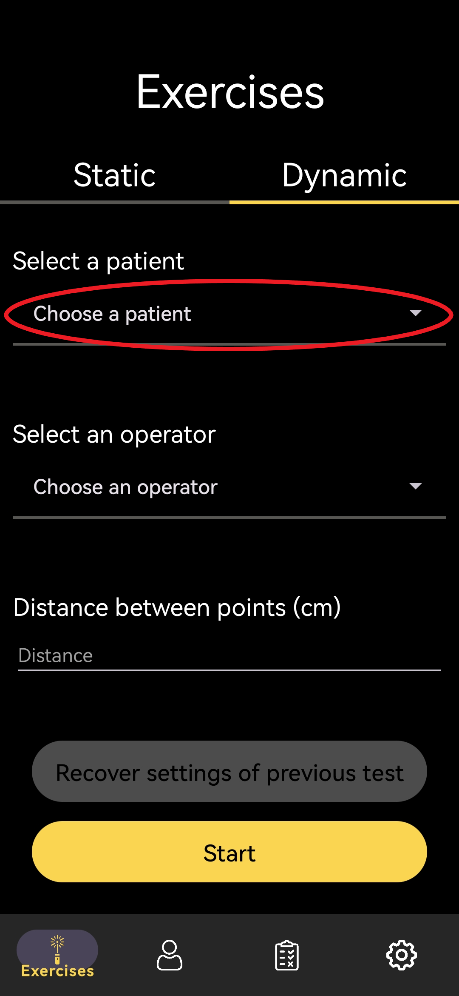 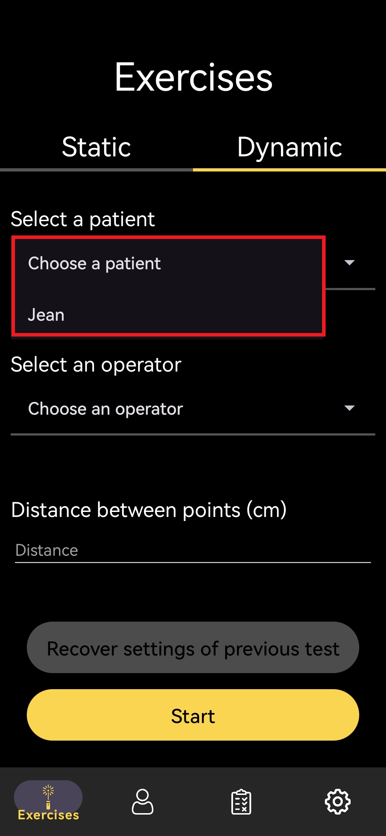

* Choose an operator in the dropdown list available by clicking on the section “Choose an operator”

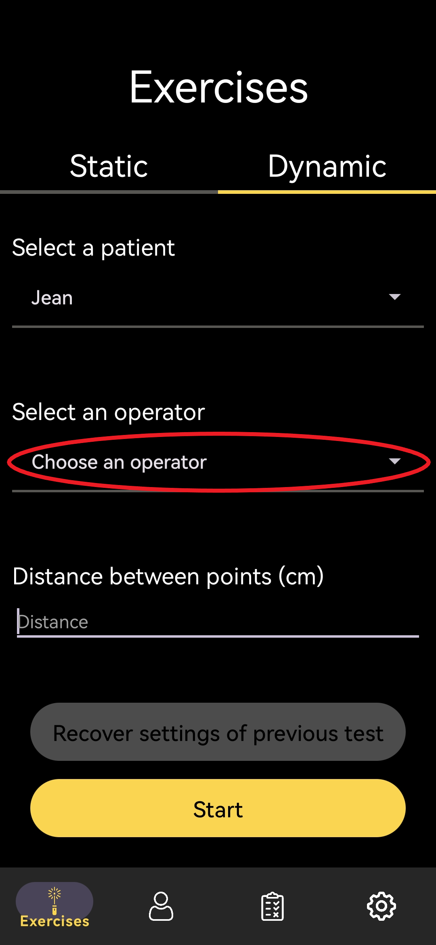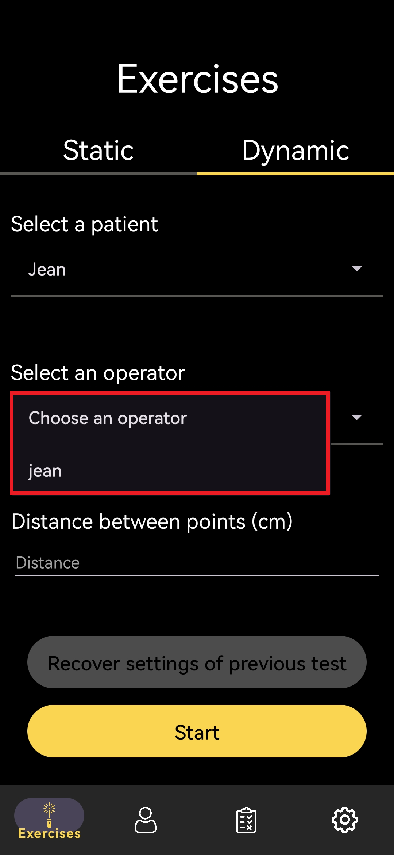

* Type the distance between the two points drawn on the whiteboard in the field “Distance between points (centimetres)”

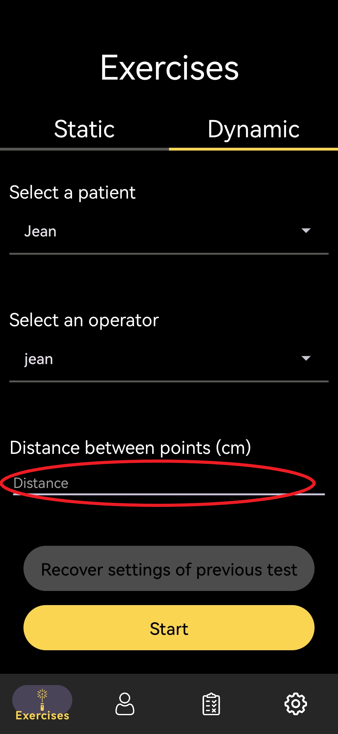

* Type the exercise duration in the field “Time of the exercise (seconds)

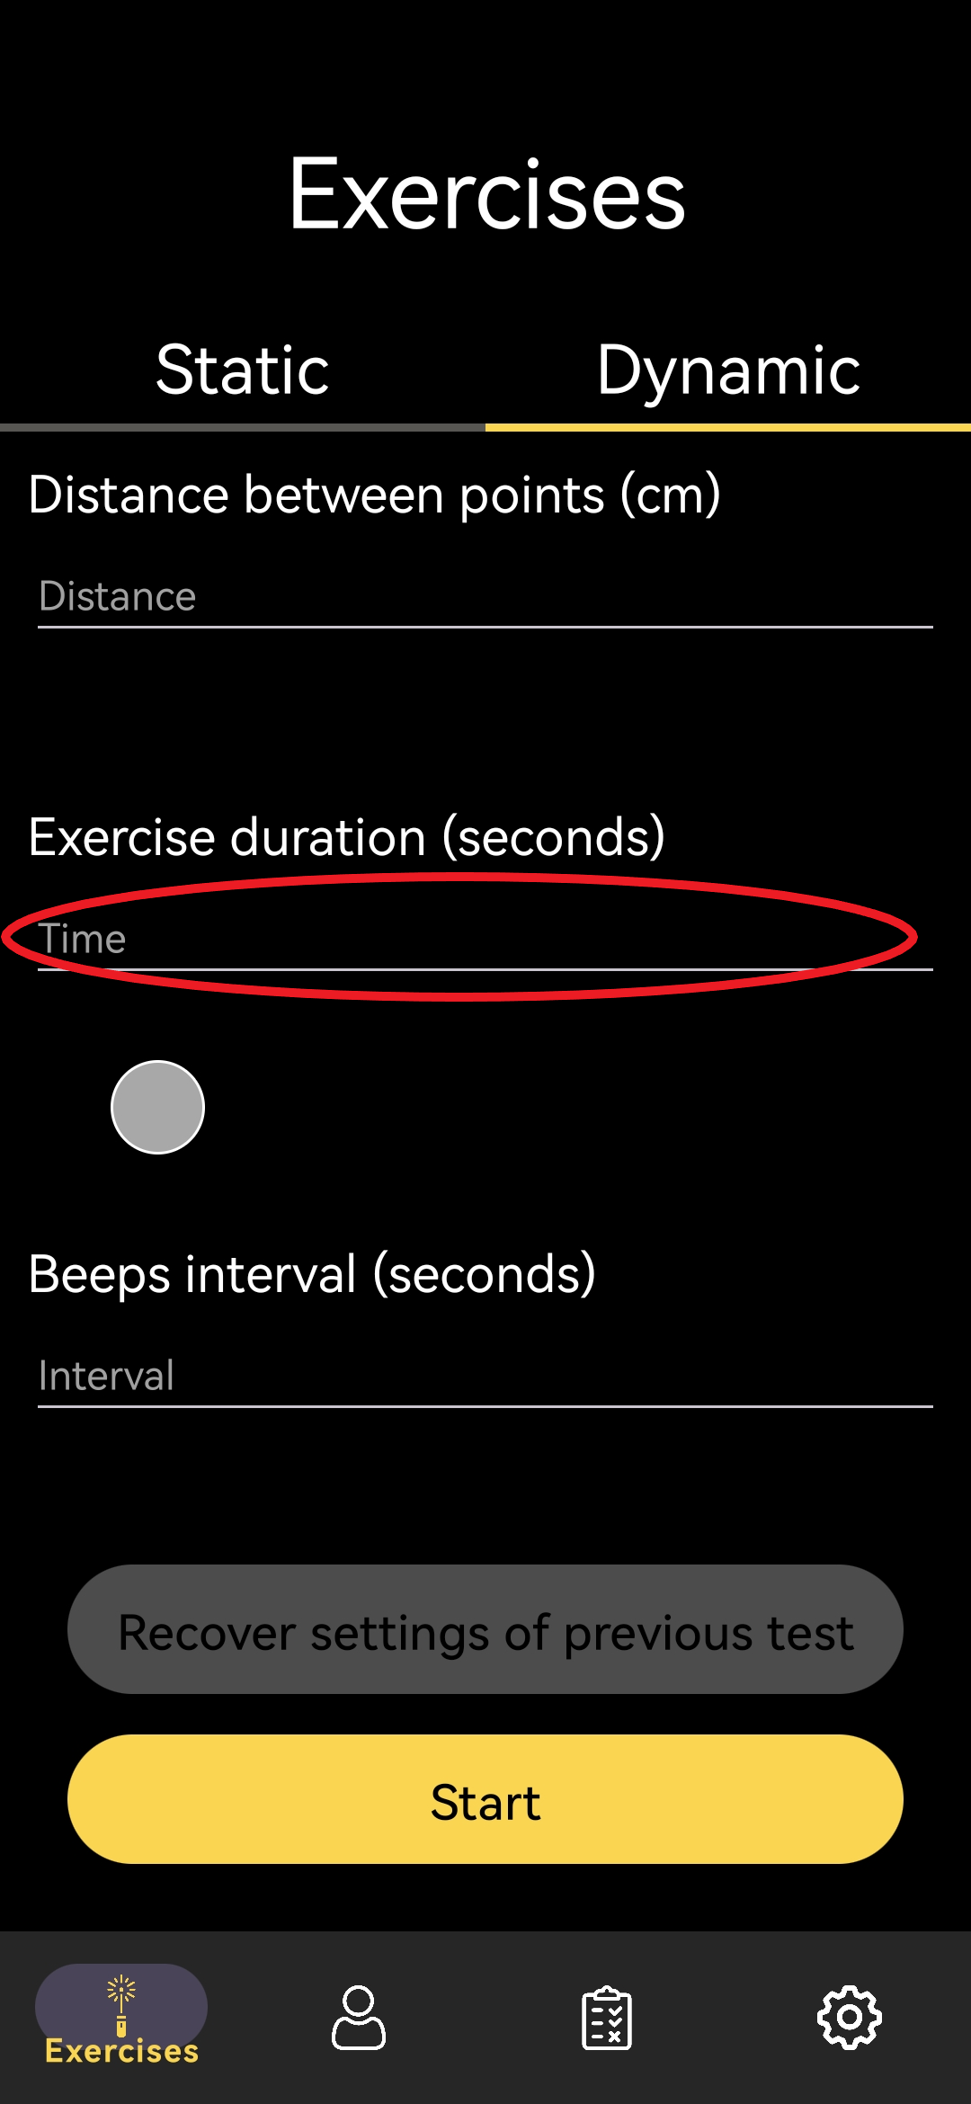

* Choose an interval for the sonor signal typing in the field “Beeps interval (seconds)” or by defining it using the slider

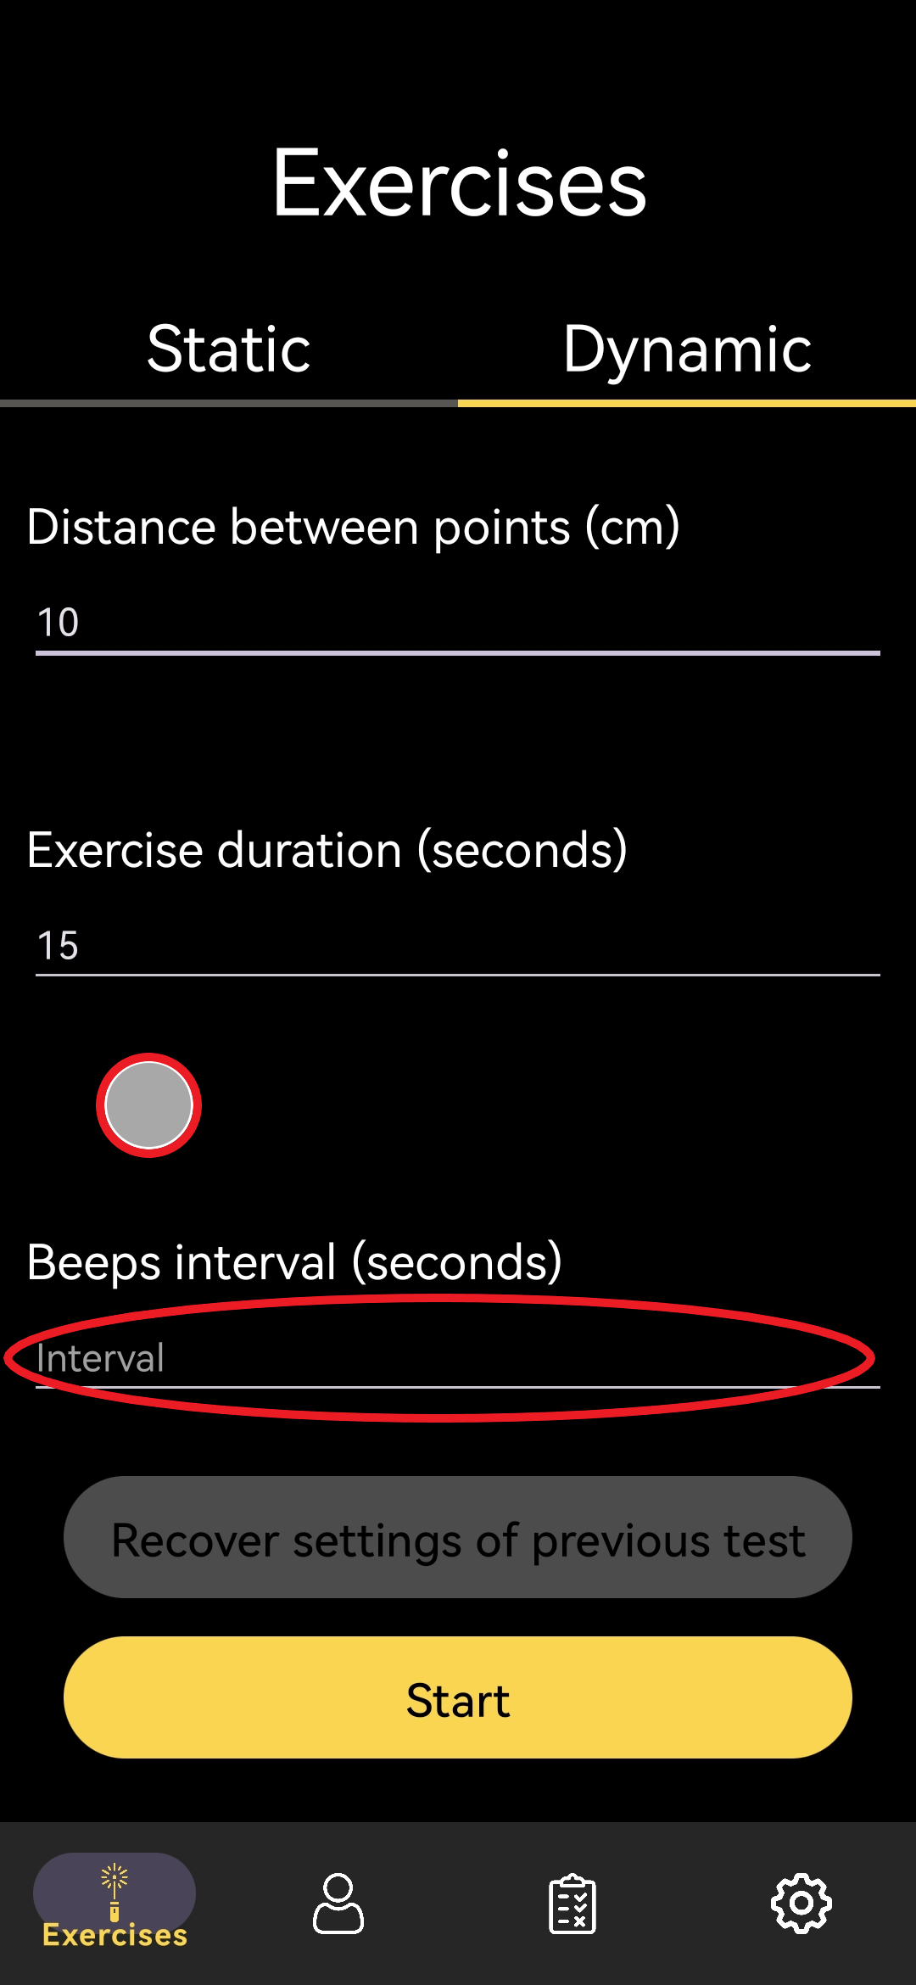

* Then, click "Start" to begin the exercise

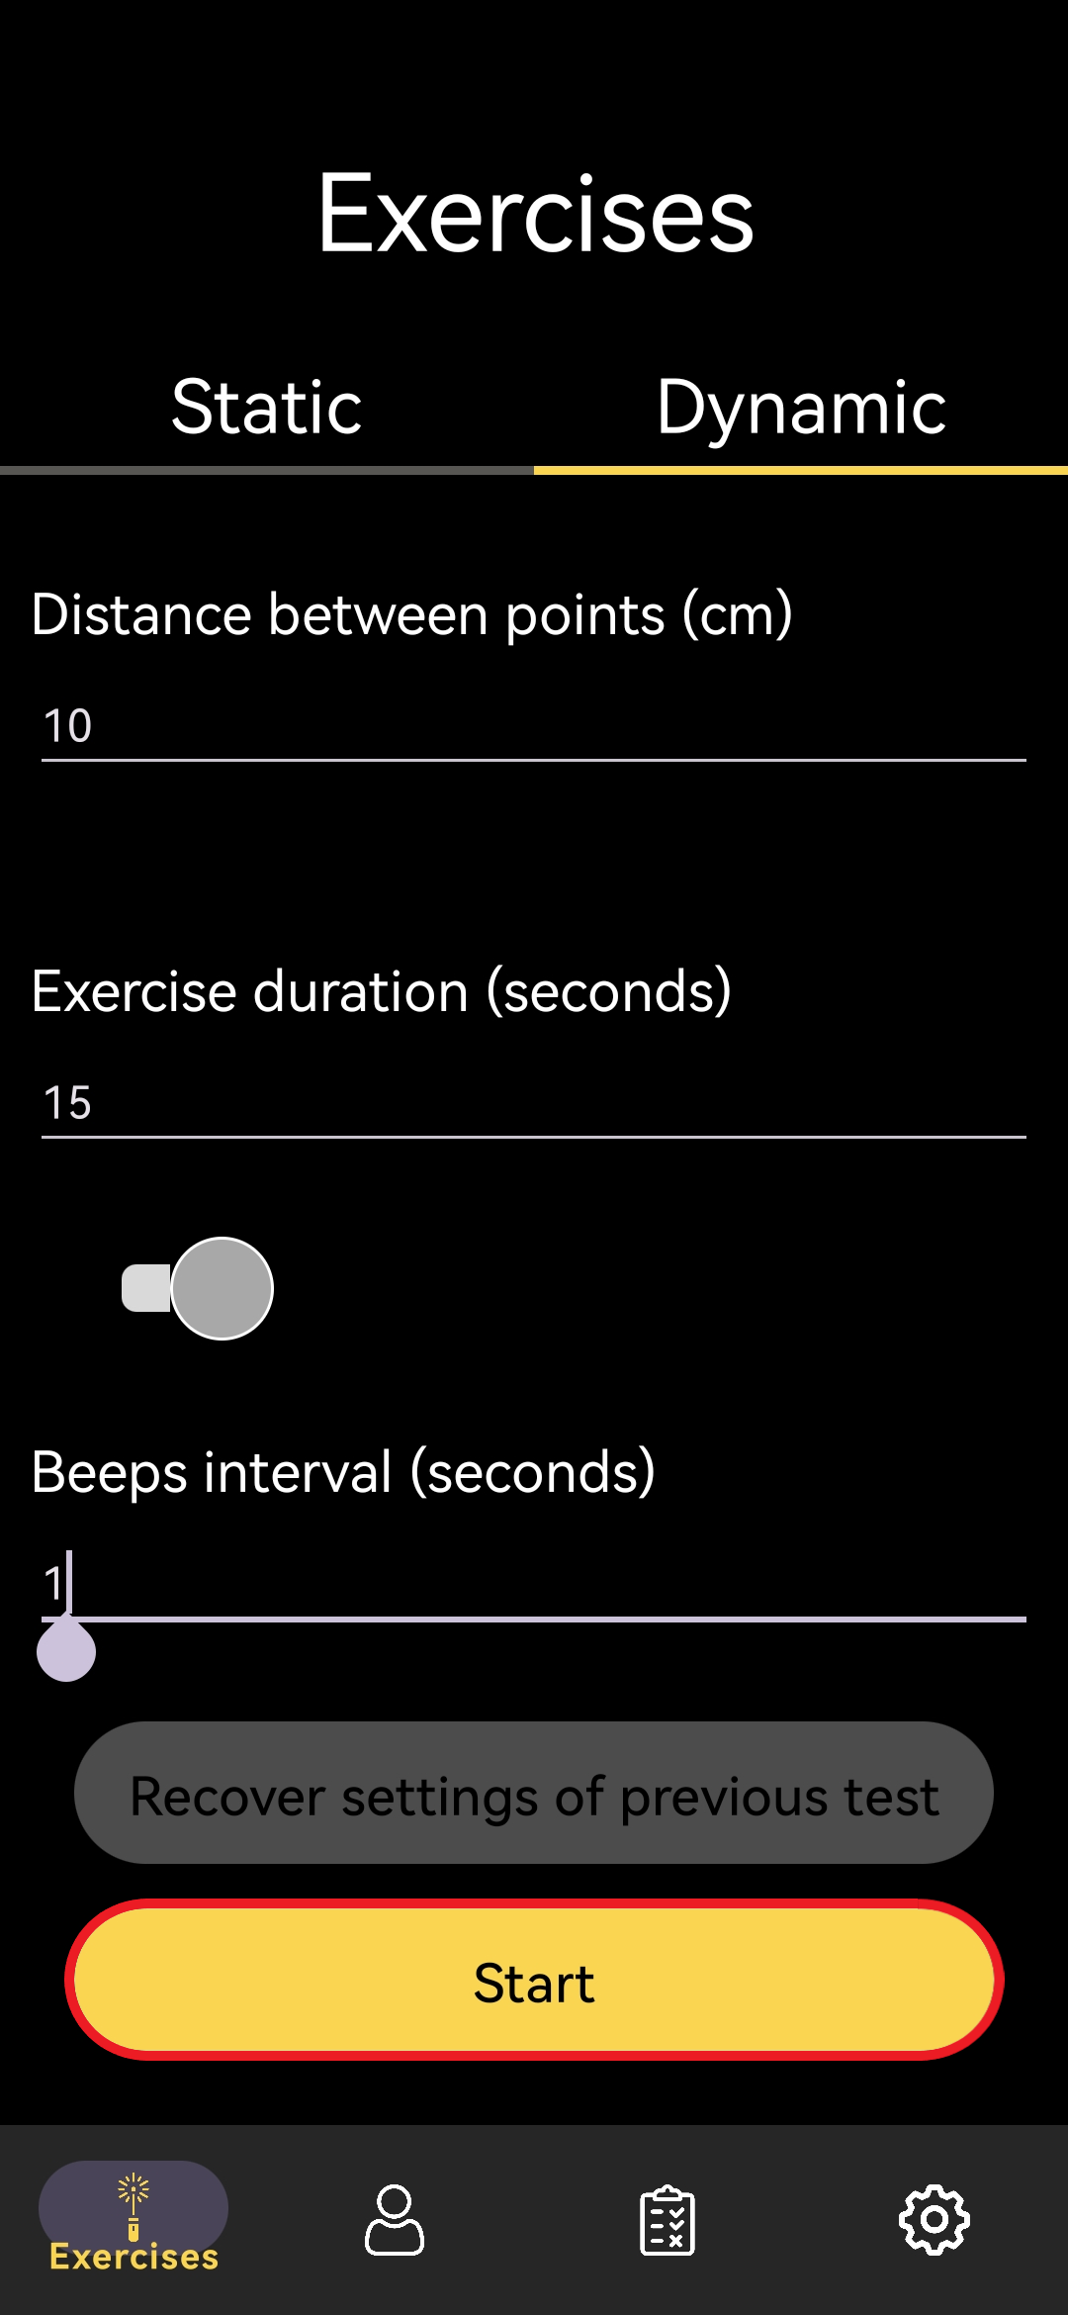

# User management

## Patient

### Add a patient

* Click on "Profiles" in the navigation menu at the bottom.

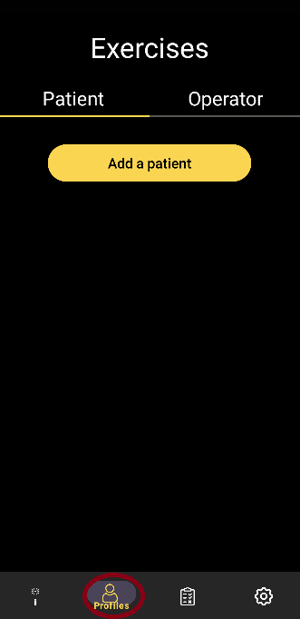

* Click on the "Add a patient" button.

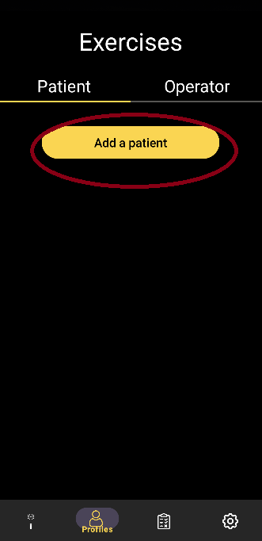

* Enter the patient's last name in the "Name" field.
* Enter the patient's first name in the "Firstname" field.
* Enter the patient's date of birth in the "Birthday" field.
* Provide any observations in the "Observation" field (optional).

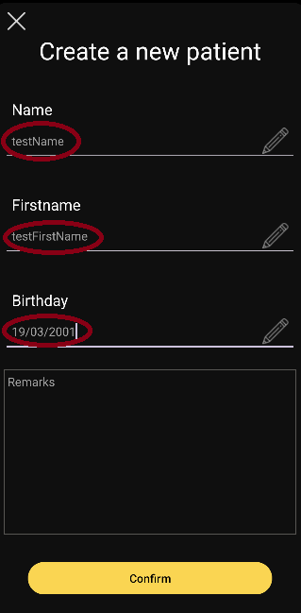

* Click on the "Confirm" button to confirm the creation of the patient and verify it on profiles section.

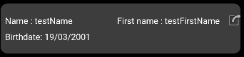

### Consult a patient

**Prerequisite**: At least, a patient is created

* Click on "Profiles" in the navigation menu at the bottom.



* Click on one of the patients from the dropdown list.

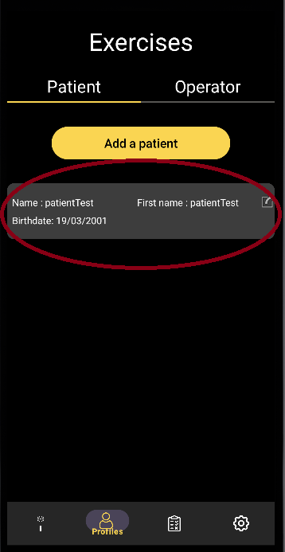

### Edit a patient

**Prerequisite**: At least, a patient is created

**WARNING**: If you edit a patient, it’s related tests won’t be updated with new informations

* Click on "Profiles" in the navigation menu at the bottom.



* Click on one of the patients from the dropdown list.

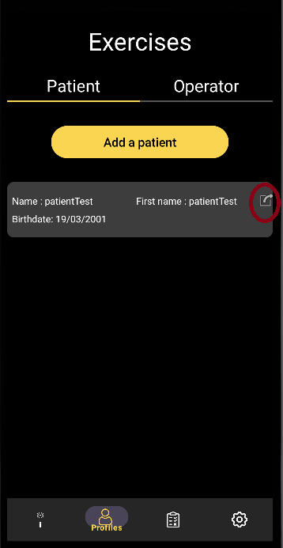

* Click on the "Name" field to modify the patient's last name.
* Click on the "Firstname" field to modify the patient's first name.
* Click on the "Birthday" field to modify the patient's date of birth.
* Click on the "Observation" field to modify the patient's observation.

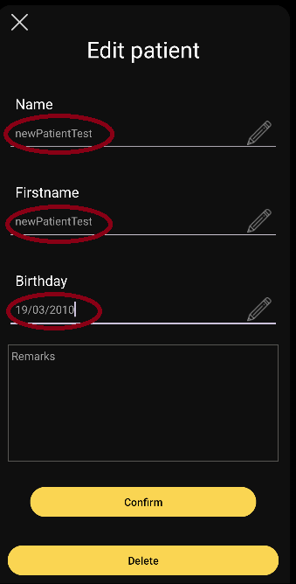

* Click on the “Confirm” button and verify your update in the profiles section

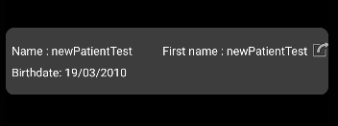

### Delete a patient

**Prerequisite**: At least, a patient is created

* **WARNING:** If you delete the patient, it’s related tests won’t be deleted Click on "Profiles" in the navigation menu at the bottom.
* 
* Click on one of the patients from the dropdown list.



* Click on the "Delete patient" button at the bottom.

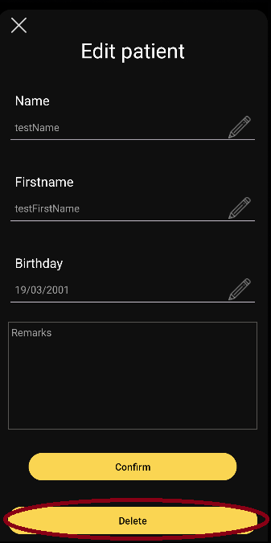

* Verify the deletion

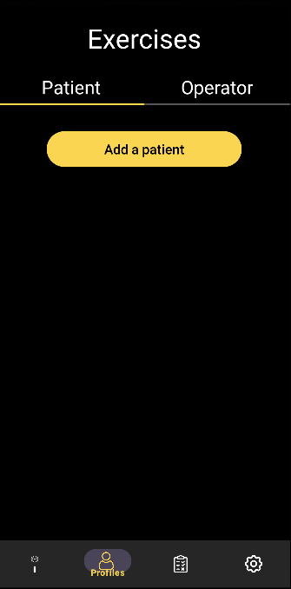

## Operator

### Add an operator

* Click on "Profiles" in the navigation menu at the bottom.



* Click on the "Operator" section.

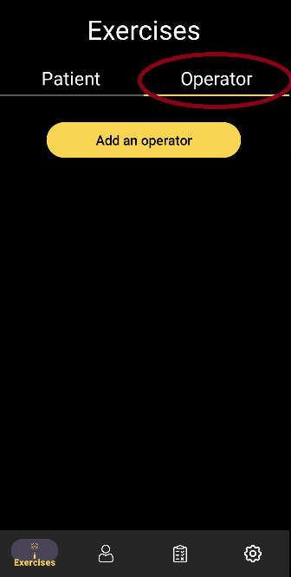

* Click on the "Add an operator" button.

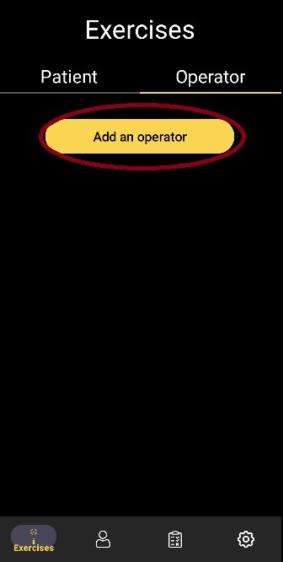

* Enter the operator's last name in the "Name" field.
* Enter the operator's first name in the "Firstname" field.

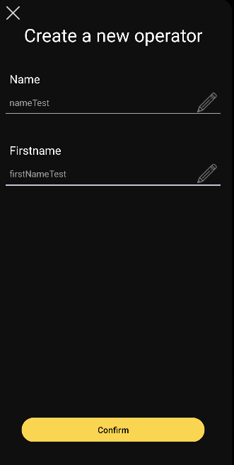

* Click on the "Confirm" button to confirm the creation of the operator.

### Consult an operator

**Prerequisite**: At least, an operator is created

* Click on "Profiles" in the navigation menu at the bottom.



* Click on the "Operator" section.
* Click on one of the operators from the dropdown list.

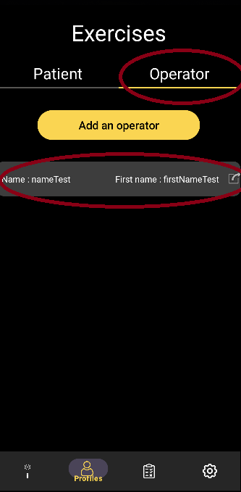

### Edit an operator

**Prerequisite**: At least, an operator is created

**WARNING**: If you edit a patient, it’s related tests won’t be updated with new informations

* Click on "Profiles" in the navigation menu at the bottom.



* Click on the "Operator" section.
* Click on the Edit button for the operator of your choice in the list.

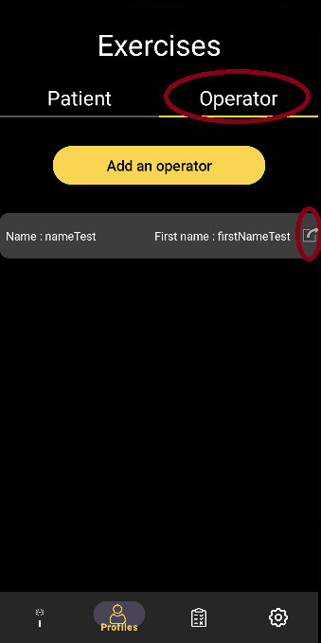

* Click on the "Name" field to modify the operator's last name.
* Click on the "Firstname" field to modify the operator's first name.

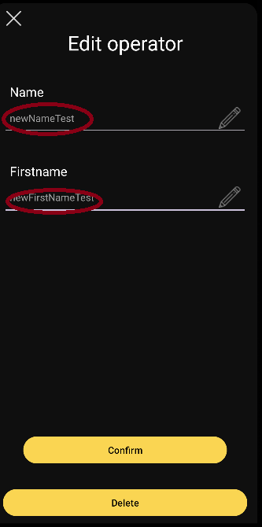

* Click on the “Confirm” button
* Check your modifications

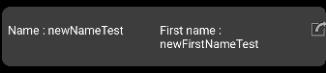

### Delete an operator

**Prerequisite**: At least, an operator is created

**WARNING:** If you delete the operator, it’s related tests won’t be deleted Click on "Profiles" in the navigation menu at the bottom.

* Click on "Profiles" in the navigation menu at the bottom.



* Click on the "Operator" section.
* Click on one of the operators from the dropdown list.



* Click on the "Delete operator" button at the bottom.

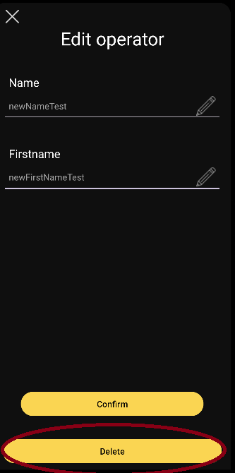

* Verify the deletion

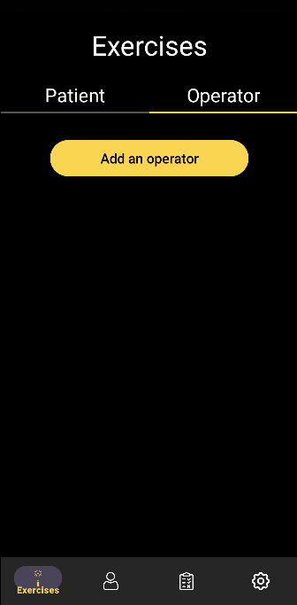

# Tests results management

## Consult a test

* Click on 'Tests' in the navigation menu at the bottom.

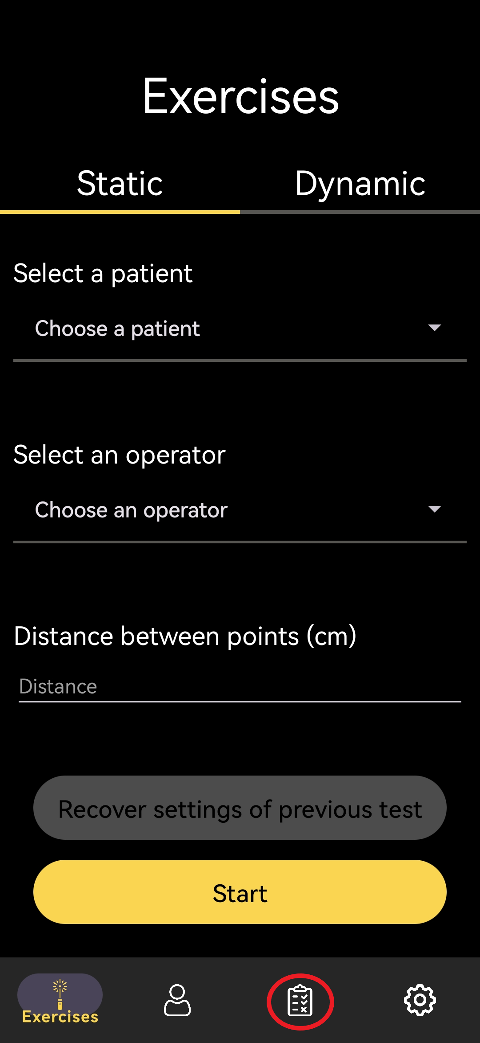

* Click on one of the tests from the dropdown list

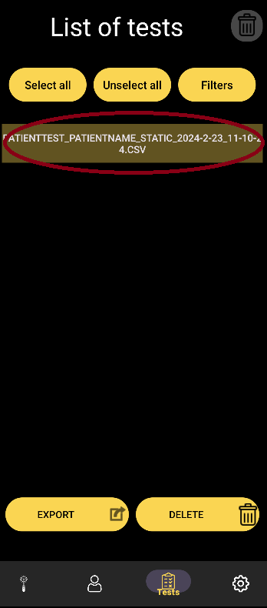

## Consult a result as a graph

* Click on 'Tests' in the navigation menu at the bottom.



* Click on one of the tests from the dropdown list.



* Click on 'View Graphics'.

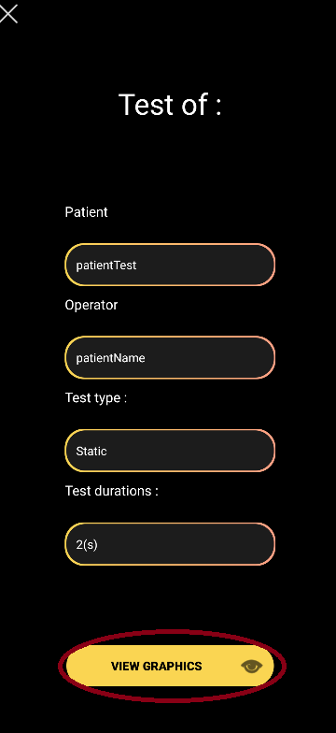

* Select a graph either (from left to right) X over time, X and Y over time, Y over time by clicking on the desired choice at the bottom

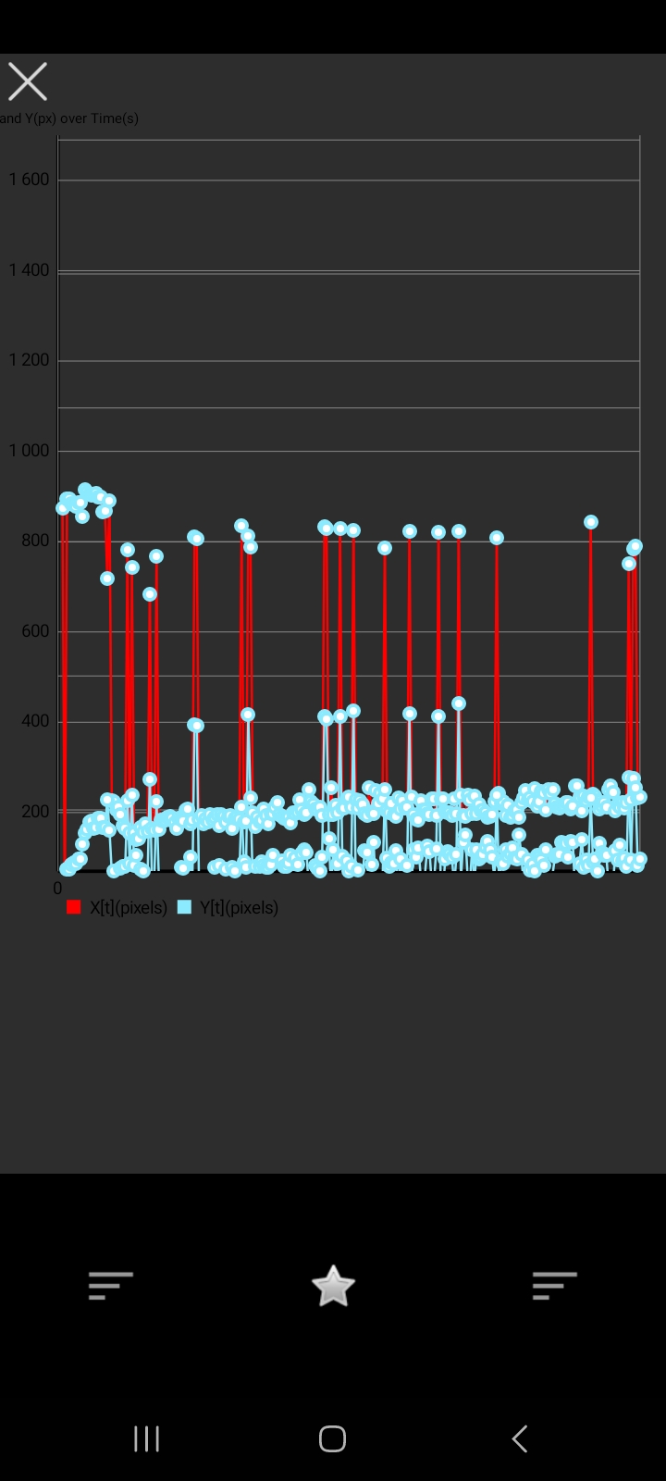

## Delete a test

* Click on 'Tests' in the navigation menu at the bottom.



* Select the test to delete from the dropdown list by pressing and holding it (you can now select additional tests by clicking on them).

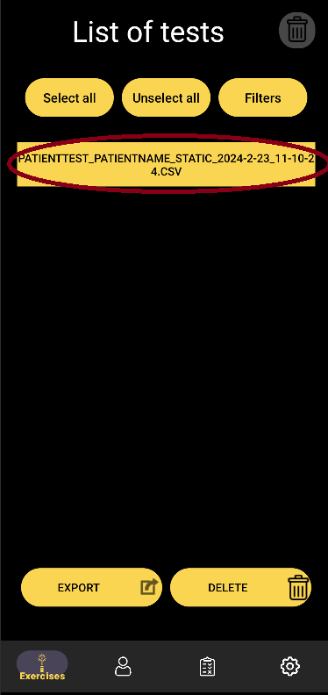

* Click on the 'Delete' button at the bottom.

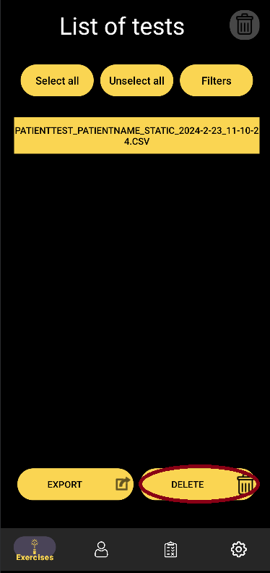

* A popup window will open, click on 'Continue' if you are sure you want to delete the selected tests.

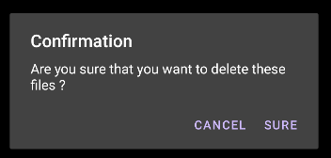

## Exports tests

Prerequisite: having a valid email address registered in the export mode settings.

* Click on “Tests” in the navigation menu at the bottom.



* Select one or more CSV files by holding down on them. (A single tap opens a window with test information.)



* Click on the “Export” button

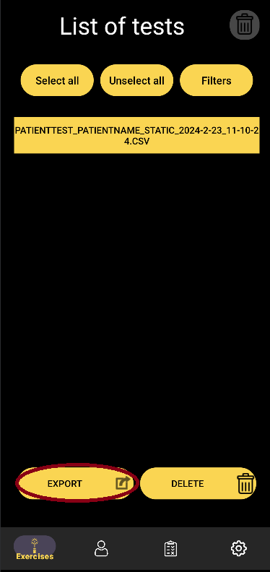

* Choose your email client (Gmail, Outlook, etc.).

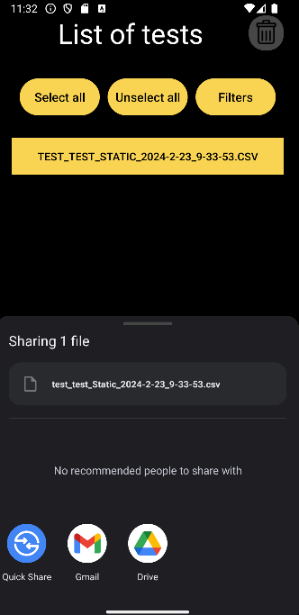

# Export mode settings

* Click on “Settings” in the navigation menu, at the bottom of the screen

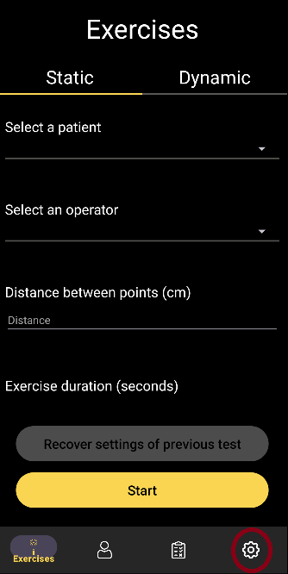

* Click on the Email Button
* Enter a valid email where you want the results to be sent

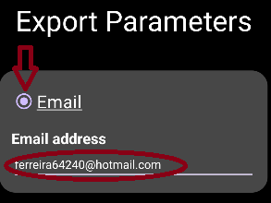

* Click on “Save” to save your modifications

